North Pocono Pre-season
Baseball Camp

When: Sunday March 11, 2018
Where: North Pocono High School
Cost: $20 for campers within the boundaries of NPSD/ $25 all others
Age: Seven through twelve years of age
Time: Session One (11a.m. to 1:30p.m.) 7-9 year olds
Session Two (2p.m. to 4:30p.m.) 10-12 year olds
Contact: Coach Brian Jardine (bjardine@npsd.org) with questions or registration

Camp objective: To help young players who are sincerely interested in playing baseball and desire to develop their skills and reach a higher level of performance. Major emphasis will be placed on fundamentals.

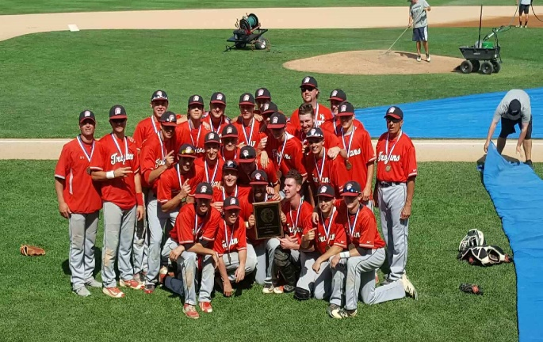 | 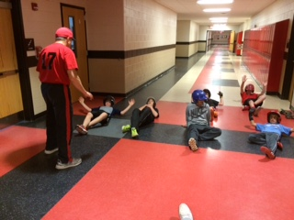

Event will also offer:
--- Raffle prizes
--- Drinks and NP Baseball gear for sale
--- Q & A for parents

**Each camper will receive one raffle ticket, additional tickets may be purchased the day of the event.

